ASSIGNMENT NO # 02

NAME # NOMAN AMJAD

CLASS # BSCS 4B

REG NO # 21-ARID-654

SUBMITTED TO # MAM SEHRISH BATOOL

Q1.

Write a program to print alphabets from A TO Z using loop?

Code:

.model small

.stack 100h

.data

.code

main proc

mov cx,26

mov dl,65

L:

mov ah,2

int 21h

add dl,1

loop L

mov ah,4ch

int 21h

main Endp

End main

**Output:**

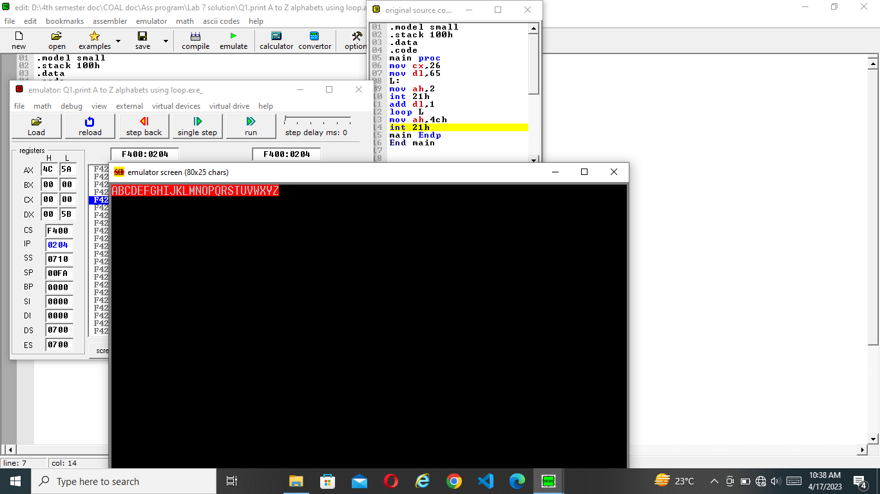

**Q2.**

Wirte a program to print a array a,b,c using loop?

Code:

.model small

.stack 100h

.data

arr1 db 'a','b','c'

.code

main proc

mov cx,3

mov ax,@data

mov ds,ax

lea si,arr1

L:

mov dl,[si]

mov ah,2

int 21h

inc si

loop L

mov ah,4ch

int 21h

main endp

end main

**output:**

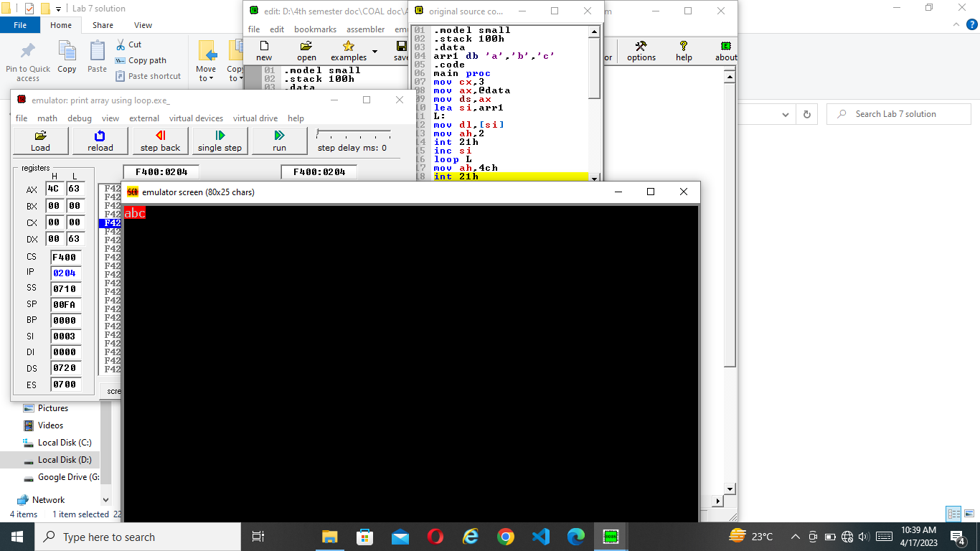

Q3.

Write a program to print an array dup(a,a,a)using loop?

Code:

.model small

.stack 100h

.data

arr1 db 3 dup('a')

.code

main proc

mov cx,3

mov ax,@data

mov ds,ax

lea si,arr1

L:

mov dl,[si]

mov ah,2

int 21h

inc si

loop L

mov ah,4ch

int 21h

main endp

end main

**output:**

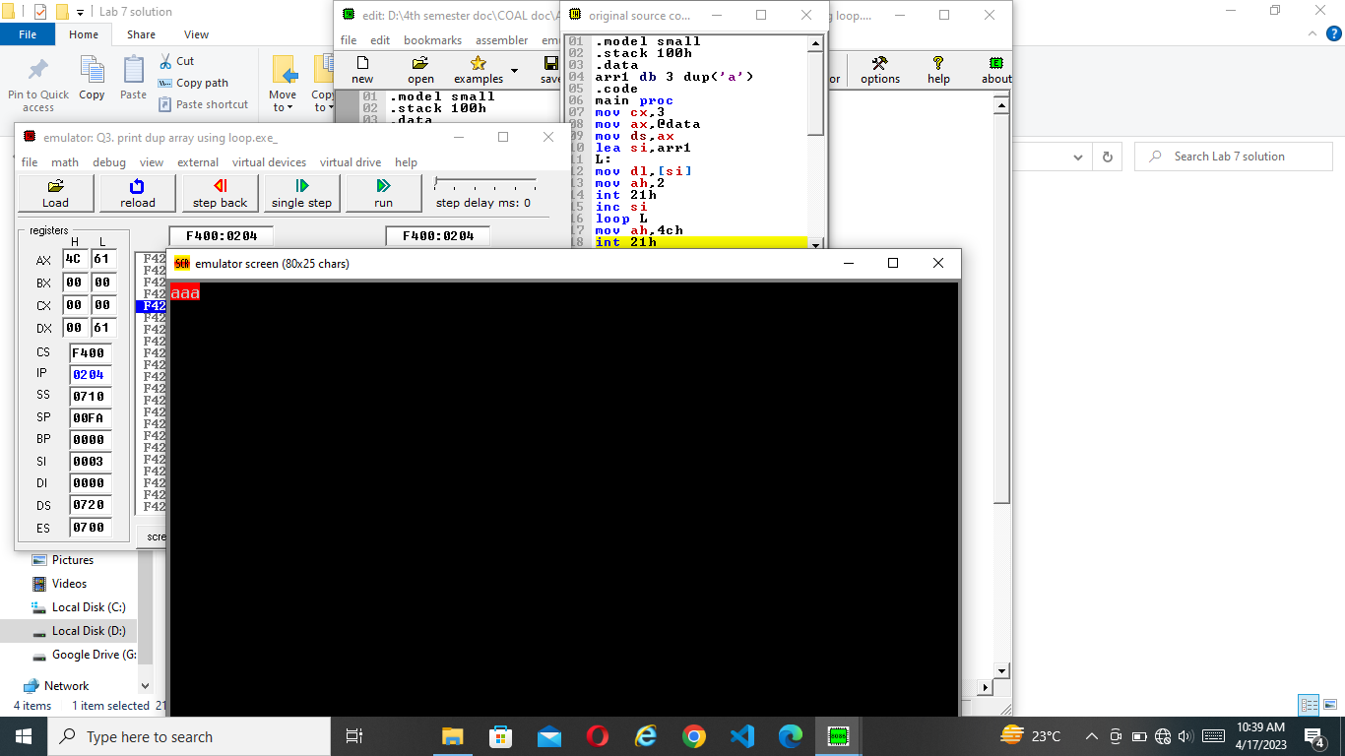

Q4.

Write a program to print 0-9 each on separate line using loop?

Code:

.model small

.stack 100h

.data

.code

main proc

mov cx,10

mov bl,48

L:

mov dl,bl

mov ah,2

int 21h

inc bl

mov dl,10

mov ah,2

int 21h

mov dl,13

mov ah,2

int 21h

Loop L

mov ah,4ch

int 21h

main endp

end main

**output:**

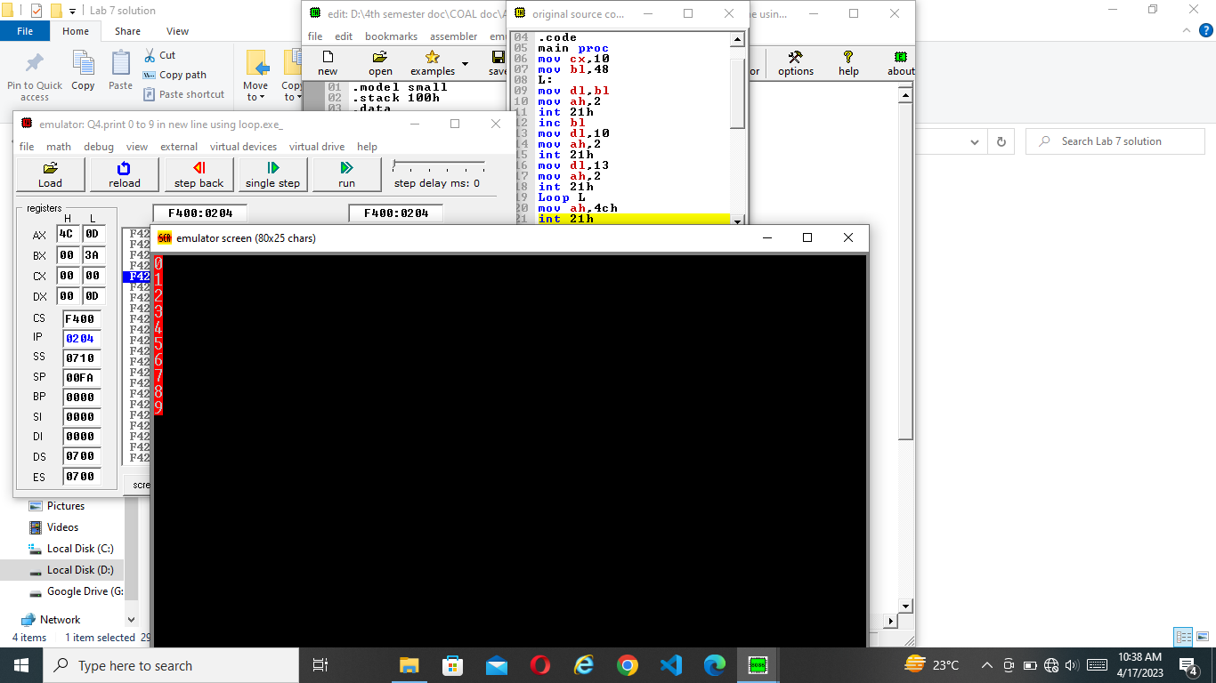

**THE END**